Marshmallow Bot
Quick-Start Guide for a Mostly Assembled Bot
BUILD • PROGRAM • DRIVE • CREATE
Start here if the chassis, wheels, motors, battery holder, and controller board are already assembled.

Before You Begin
- ☐ 4 fresh AA batteries
- ☐ A phone, tablet, or computer with Wi-Fi
- ☐ A clear indoor test area
- ☐ Mini marshmallows, only if the launcher is installed
SAFETY: The mousetrap mechanism can snap fingers and the launcher can propel objects. Keep hands clear while cocked. Use only soft mini marshmallows. Never aim toward faces, people, animals, windows, or fragile objects. Adult supervision is recommended.
1 | Inspect the bot  Confirm that both drive wheels turn freely, the battery holder is secure, and no wires are pinched. The optional launcher includes a mousetrap, a trigger servo, and a launching arm or spoon.

2 | Check the controller orientation  The ESP32-C3 Super Mini must be seated in the expansion board with the USB-C connector on the same side as the expansion board’s white connector. The board can physically be installed backward, so verify this before applying power.

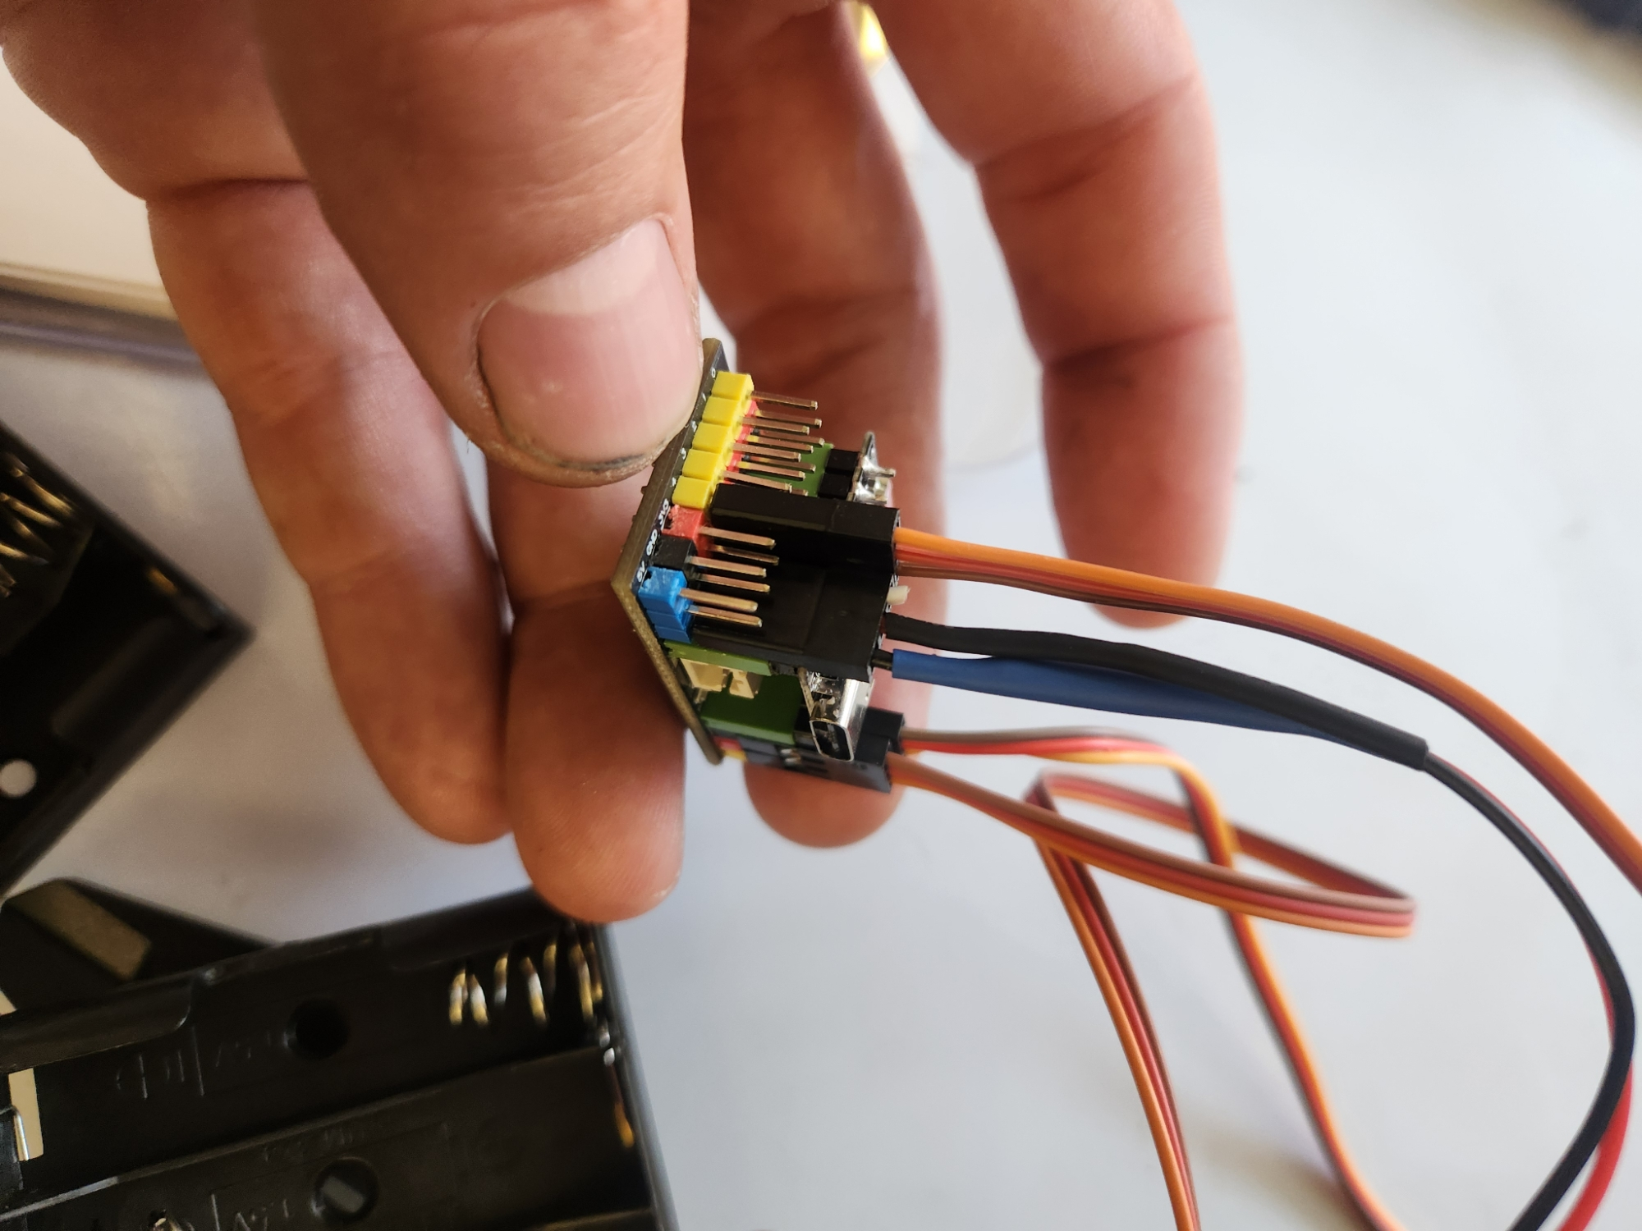
Controller installed in the expansion board
3 | Check the three servo plugs  Each servo plug has signal, power, and ground wires. Match the yellow/orange signal wire to the yellow signal row and the brown/black ground wire to the black row. The two wheel servos connect on opposite sides of the board. The optional trigger servo connects beside the right wheel servo as shown.

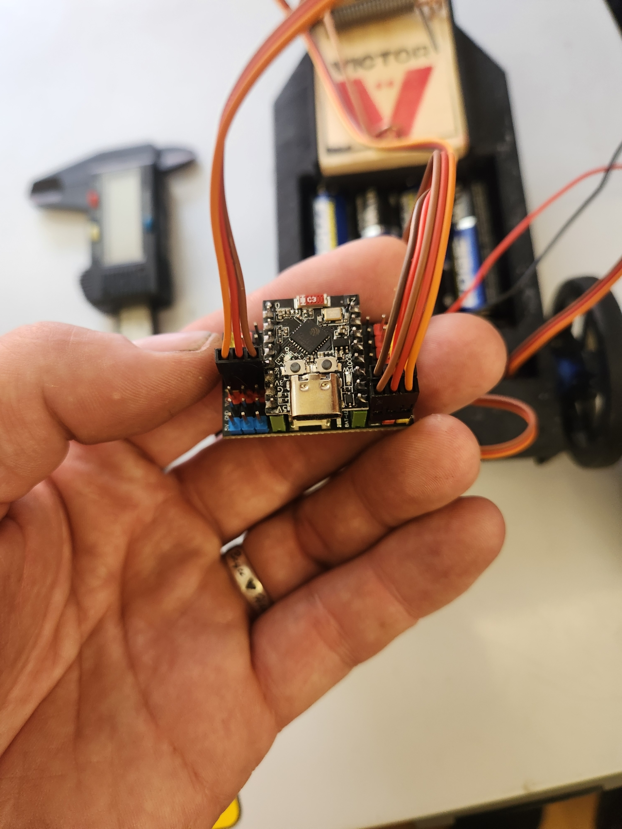  Left-side connection | 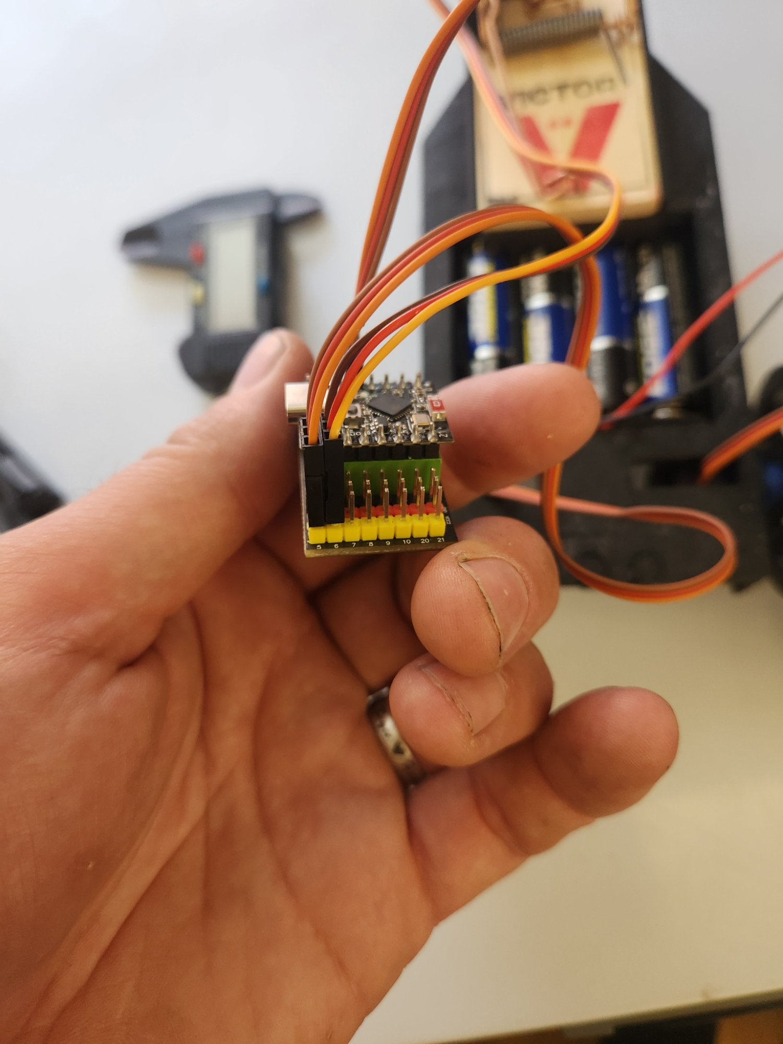  Right-side and trigger connections
4 | Install batteries and connect power  Install four AA batteries. With the controller unplugged from USB, connect the battery plug only after checking polarity. On this build, the blue-marked wire aligns with the blue row and the black-marked wire aligns with the black row. Reversing this connector can damage the board or wiring.

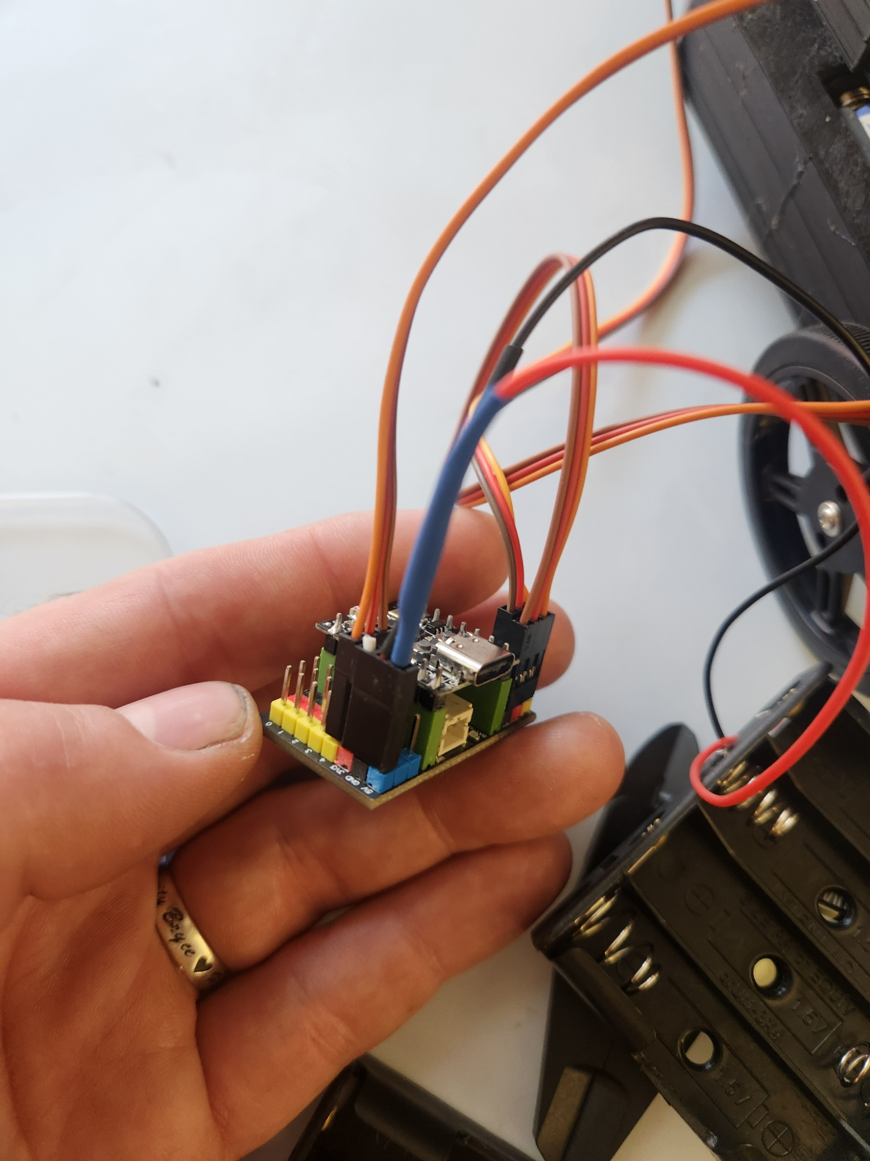
Battery-power connector orientation
5 | Connect to the robot Wi-Fi  After power is connected, an LED should light. On a phone, tablet, or computer, open Wi-Fi settings and join “MarshMallowBot” unless the network name was customized. Password: 12345678. The network controls the bot and normally does not provide internet access.

6 | Open the controller  Open a web browser and enter 192.168.4.1 in the address bar. The driving interface should appear. Test Forward, Reverse, Left, and Right with the wheels raised slightly off the table first.

7 | Test the launcher, if installed  Keep hands and bystanders clear. Cock the mousetrap only when ready to test. Press Fire once and verify that the servo horn pushes the mousetrap trigger without binding. Adjust the horn position only with the mousetrap released and power disconnected.

Quick Troubleshooting
Problem | What to check
No light on the board | Disconnect power immediately. Recheck fresh batteries, the battery holder, and connector polarity.
Wi-Fi network does not appear | Wait 15 seconds, then disconnect and reconnect power. Stay close to the bot and check that the ESP32 board is fully seated.
Web page will not open | Confirm the device is connected to the bot’s Wi-Fi, then type 192.168.4.1 directly into the browser address bar.
One wheel runs backward | First verify that the left and right servos are connected to the intended positions. A software direction setting may need to be changed.
Bot moves when it should be stopped | A continuous-rotation servo may require neutral calibration or a software stop-value adjustment.
Fire button does not release the trap | With the trap released and power disconnected, check trigger-servo connection and horn angle.

Project Files and Updates
Scan the QR code for code, 3D-print files, build information, and future updates. https://github.com/bryceehill/MarshmallowBot
